Slides Breakdown – what we need?

- Requirements | Use Cases | Story Cards | DDD event-storm output | anything else?
- Archi Characteristics
  - Availability
  - Reliability
  - Security
  - Scalability
  - Elasticity
  - Deploy ability
  - Performance
  - View Others
- Apply Archi Characteristics within our requirements (why and how). What characteristic will be sacrificed for another etc.
- Component Identification - System entities
- Avoid the entity trap – trip manager (too vague)
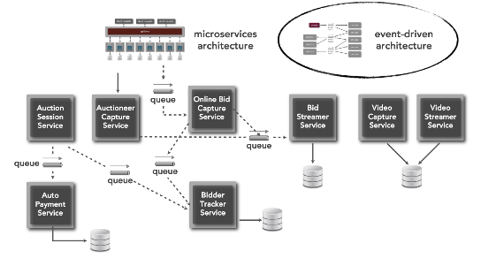
- Workflow Approach – Happy paths for specific scenarios (modules that will handle these workflows)

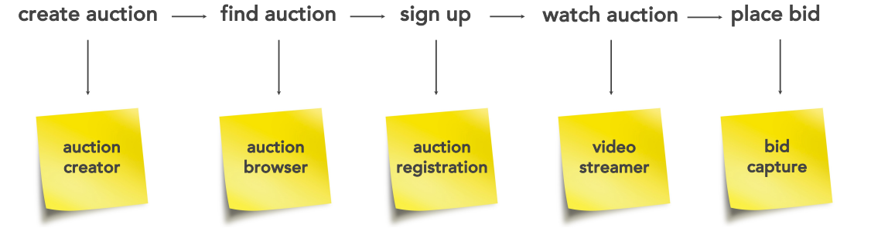
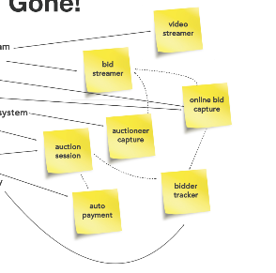
- Actor/Action Approach – Main actors (User – What user can do in the system map)
- Diagram/Detailed Diagram how components/handlers communicate together.
- Review Judges Criteria
- Previous submissions (we say this already)
- explain Why rather than How
- ADRs (Title, Status, Context, Decision (the why), Consequences)

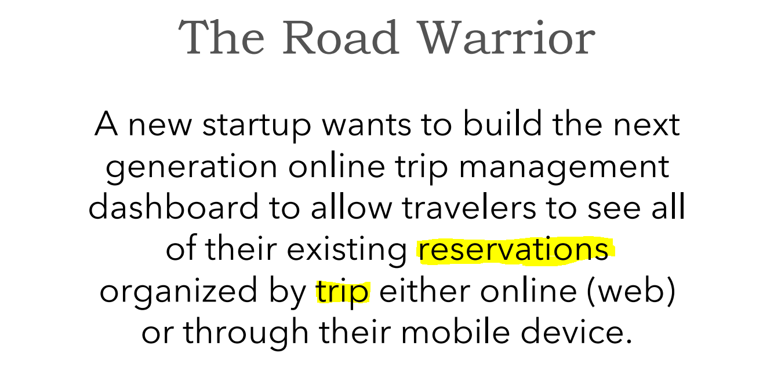
Keywords/Entities
Trip (Like Italy 2022)
Reservation (Like Visit to Colosseum)

Front End User Entry Points

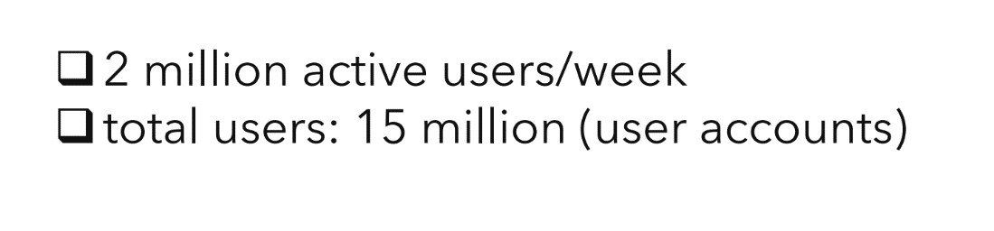

NFRs
huge load
high availability
rich UI/UX
scalability (potentially during pea seasons)

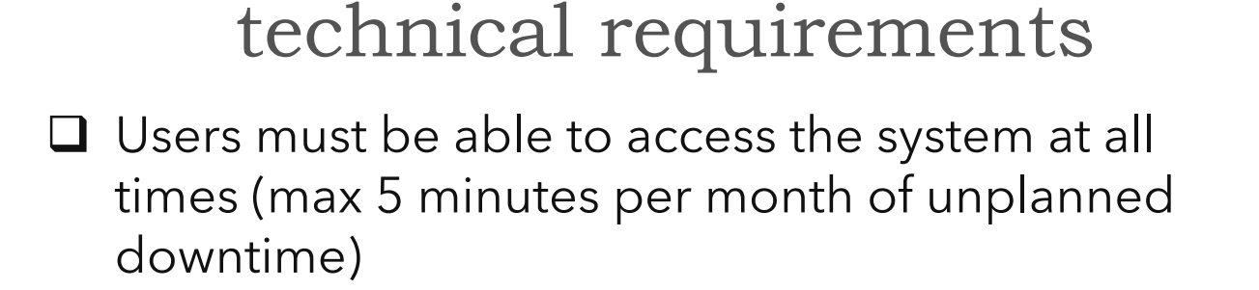

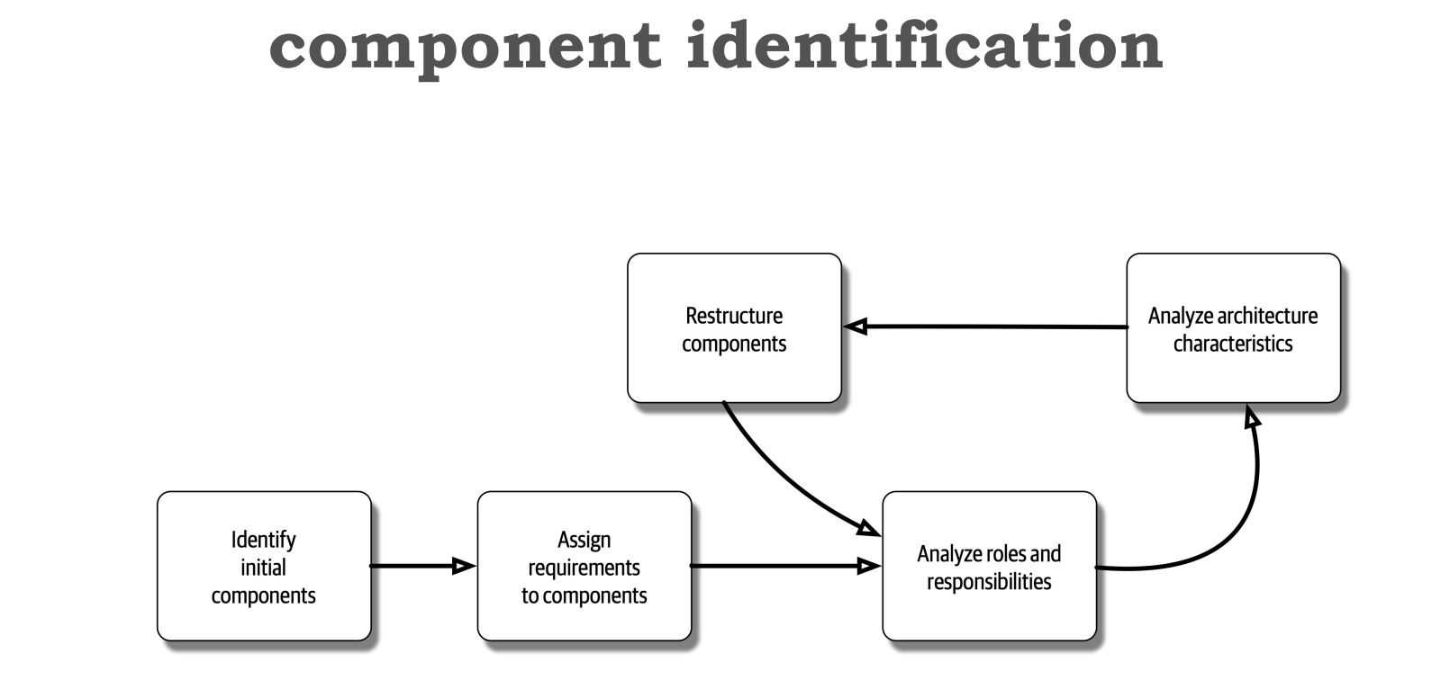

IDENTITY/USER
TRIP
TRIP ITEM
RESERVATION

Workflow approach
Happy path

login
search trip
create trip item/reservation

User
Authenticator
Trip finder
Reservation
Capture

sign up
create trip
create trip item/reservation
view trip

Identity
Creator
Trip Capture
Reservation
Capture
Trip Reader

FE User
Manually manage trip (add/update/delete)
Manually manage reservation (add/update/delete)
Group reservations/trip items under a trip
Share trip in Social Media Platform 
View eoy summary report
Request for Help

System
Third Party data reader job (polling every 5mins - requirement)
- SABRE
- APOLLO
- User Inbox Integration
Track trip status (Upcoming/Ongoing/Memory)
Track reservation status (potential for notifications for upcoming reservations)
Airline data – delays/cancellations/gate number
Hotel reservation data
Car Rental data

Filter emails which will be included
whitelist emails

